Data exploration using the palmerpenguins dataset
Olivier Gimenez
10/25/2020

Data exploration

Motivation
In this section, we explore the data from package palmerpenguins. A recent publication from the researcher, Dr Kristen Gorman, who shared the data is Connors et al. (2020).

Data
The data are displayed below (first 10 rows) :
penguins %>%
slice(1:10) %>%
knitr::kable()
species | island | bill_length_mm | bill_depth_mm | flipper_length_mm | body_mass_g | sex | year
Adelie | Torgersen | 39.1 | 18.7 | 181 | 3750 | male | 2007
Adelie | Torgersen | 39.5 | 17.4 | 186 | 3800 | female | 2007
Adelie | Torgersen | 40.3 | 18.0 | 195 | 3250 | female | 2007
Adelie | Torgersen | NA | NA | NA | NA | NA | 2007
Adelie | Torgersen | 36.7 | 19.3 | 193 | 3450 | female | 2007
Adelie | Torgersen | 39.3 | 20.6 | 190 | 3650 | male | 2007
Adelie | Torgersen | 38.9 | 17.8 | 181 | 3625 | female | 2007
Adelie | Torgersen | 39.2 | 19.6 | 195 | 4675 | male | 2007
Adelie | Torgersen | 34.1 | 18.1 | 193 | 3475 | NA | 2007
Adelie | Torgersen | 42.0 | 20.2 | 190 | 4250 | NA | 2007

Numerical exploration
There are 344 penguins in the dataset, and 3 different species. The data were collected in 3 islands of the Palmer archipelago in Antarctica.
The mean of all traits that were measured on the penguins are:
## # A tibble: 3 x 6
## species bill_length_mm bill_depth_mm flipper_length_mm body_mass_g year
## * <fct> <dbl> <dbl> <dbl> <dbl> <dbl>
## 1 Adelie 38.8 18.3 190. 3701. 2008.
## 2 Chinstrap 48.8 18.4 196. 3733. 2008.
## 3 Gentoo 47.5 15.0 217. 5076. 2008.

Graphical exploration
A histogram of body mass per species:
penguins %>%
ggplot() +
aes(x = body_mass_g) +
geom_histogram(aes(fill = species),
alpha = 0.5,
position = "identity") +
scale_fill_manual(values = c("darkorange","purple","cyan4")) +
theme_minimal() +
labs(x = "Body mass (g)",
y = "Frequency",
title = "Penguin body mass")
## Warning: Removed 2 rows containing non-finite values (stat_bin).
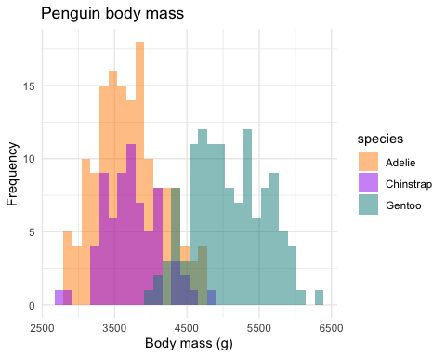

The end
The 3 species of penguins:
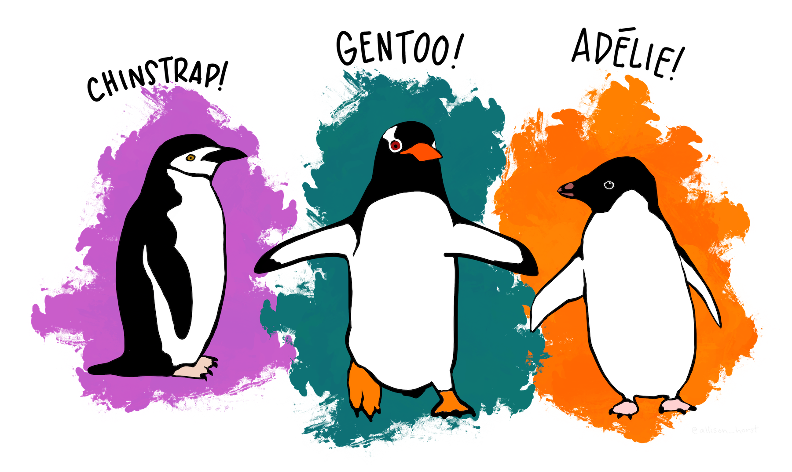

References
Connors, Brendan, Michael J. Malick, Gregory T. Ruggerone, Pete Rand, Milo Adkison, James R. Irvine, Robert Campbell, and Kristen Gorman. 2020. “Climate and Competition Influence Sockeye Salmon Population Dynamics Across the Northeast Pacific Ocean.” Canadian Journal of Fisheries and Aquatic Sciences 77 (6): 943–49. https://doi.org/10.1139/cjfas-2019-0422.

